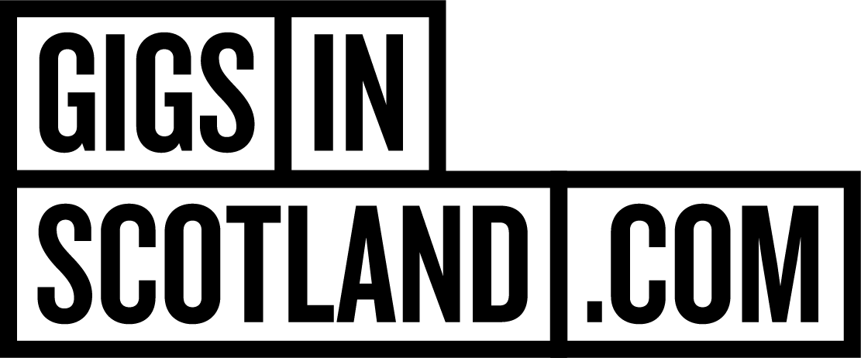
PRIZE PROMOTION NOTICE

1. This Prize Promotion Notice sets out the details of the Gigs in Scotland Billie Marten Giveaway (the "Prize Promotion") being run by DF Concerts & Events (“Our”,
"Us" and "We").

2. The Prize Promotion is subject to these terms and Our general terms and conditions
for Prize Promotions ("Prize Promotion Terms and Conditions"), which can be found at:
https://www.gigsinscotland.com/info-page/competition-tcs

3. The Prize Promotion will be run through https://www.instagram.com/gigsinscotland/

4. To enter the Prize Promotion, you must be:
a) resident in the United Kingdom;
b) able to comply with these terms and all the Prize Promotion Terms and
Conditions;
c) at least 18 years old

5. To enter the Prize Promotion, you must; have found one of the Gigs in Scotland Billie Marten Book Marks in one of the bookstores in Glasgow City Centre that are participating. You must then message @gigsinscotland on Instagram with a photo of your Billie Marten Book Mark to be in for the chance to win. The first 3 people to find a bookmark and message @gigsinscotland will win a pair of tickets.

6. The Prize Promotion will commence on Tuesday 14th October at 4pm and end when the first three winners have been selected.
7. The Prize is x1 pair of tickets to Billie Marten at SWG3, Glasgow in the 7th of November 2025. There will be one pair of tickets available per Winner and there will be 3 separate winners.
8. There is one Prize available (1 pair of tickets to Billie Marten at SWG3, Glasgow in the 7th of November 2025).

9. If you are the winner of the Prize Promotion ("Winner"), you will be notified by direct message and advised on how to receive the Prize. Please note that if you do not respond within 72 hours we reserve the right to select a different Winner.

10. Proof of identification may be required to claim the Prize.

11. This prize is x1 pair of tickets to Billie Marten at SWG3, Glasgow in the 7th of November 2025 included in the prize promotion as defined in the Prize Promotion Terms and Conditions.

12. In the event of any inconsistency between the terms of this Prize Promotion Notice
and the Prize Promotion Terms and Conditions, the terms of this Prize Promotion Notice
shall prevail.

